David Doman, Alexa Mowbray, Ryan Cathcart, and Jason Taylor

**Optimizing Product Pricing**

The Book Emporium wants to price books to optimize profits. The spreadsheet for this homework has sales data on Harry Potter book 7. For each week, the Book Emporium varied prices on Harry Potter 7 to determine a demand curve. The percent of customers who visited BookEmporium.com and purchased Harry Potter book 7 is shown in the spreadsheet. J.K. Rowling has announced a sequel to the Harry Potter series. Determine the price for the sequel.

Assumptions:

* Demand of the sequel to that of Book 7
* 100,000 customers will consider The Book Emporium when purchasing a book
* The Book Emporium pays the publisher $5.00 for each book
* The data used for predictions is based on a power model

1. *Regression analysis*
   1. *Graph the percent purchased against price*

Please see the below regression analysis performed in Excel as a representation of the percent purchased compared to price.

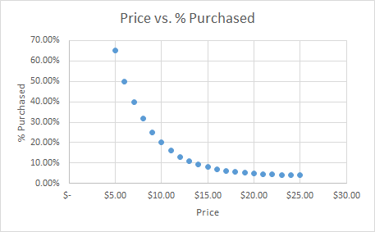

* 1. *Perform a regression using power regression to determine the predicted % column*

Oftentimes in practical application, especially in cases concerning sales, data may present growth which is non-linear. In these cases, it is appropriate to perform a Power Regression, which assumes that a response variable is proportional to an explanatory variable raised to a power.

Based on the output of that analysis (attached), the below curve was created.

* + 1. *Graph the new curve*

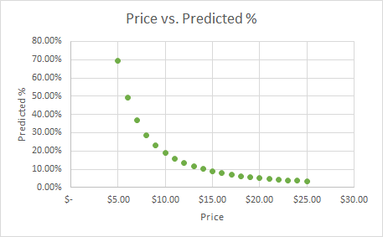

* + 1. *Estimate the equation of the line*

The equation of the line is the following: y= 14.0985 - 1.8721x.

* + 1. *What does the R2 mean?*

For this line, the R2 is equal to 0.67858. What this means, is that 68% of the book sales can be explained by the change in price.

* 1. *Assuming there are 100,000 customers who visit your website and the publisher cost is $5.00, estimate the number of books sold (predicted sales column)*

Given the assumption that 100,000 customers will visit the website, we can predict total sales to be 338,067 units broken out by predicted %:

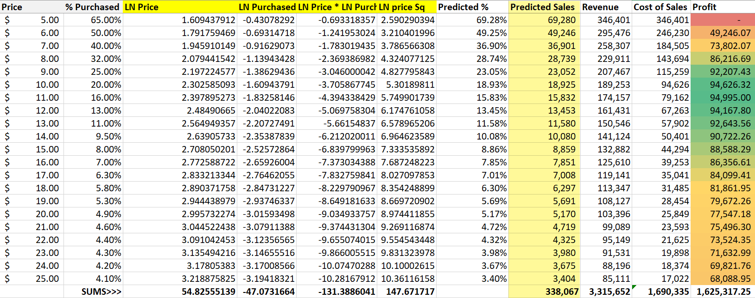

* 1. *Calculate the revenue column:*

To calculate revenue, a simple multiplication formula in excel yielded predicted revenue based on (predicted sales * price point) of $3,315,652.

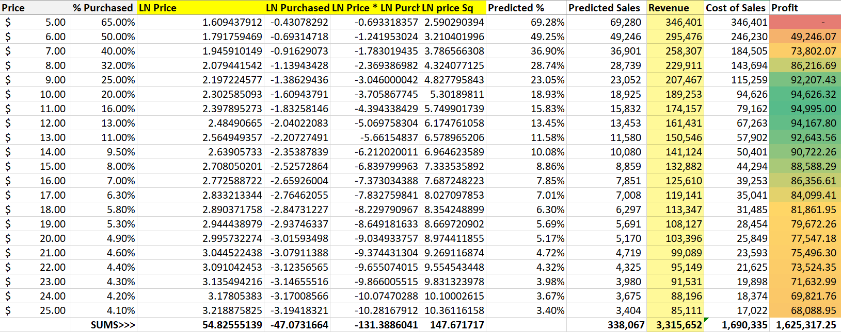

* 1. *Calculate the profit column ((price – book cost) * predicted sales)*

Total profits at all predicted sales levels equals $1,625,317.

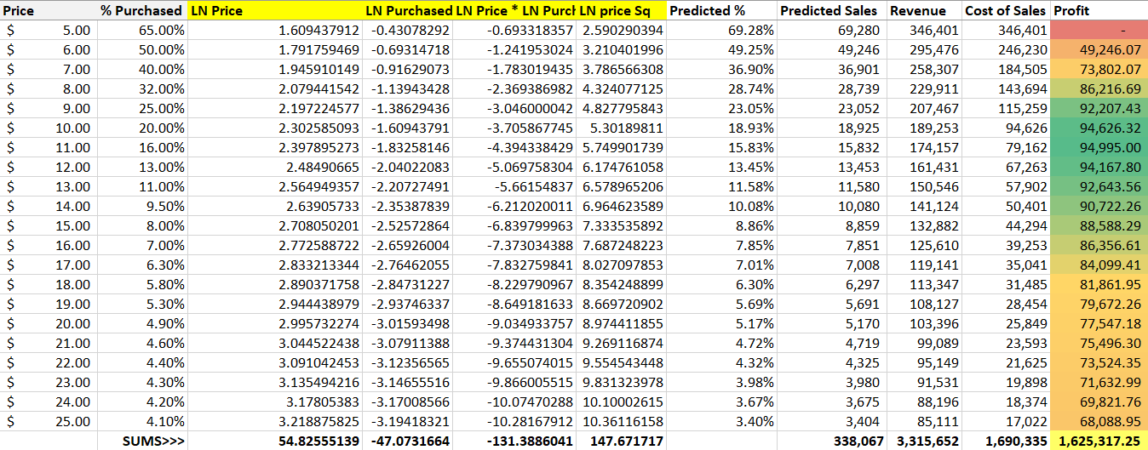

* 1. *Use conditional formatting to highlight the profit values for all prices*

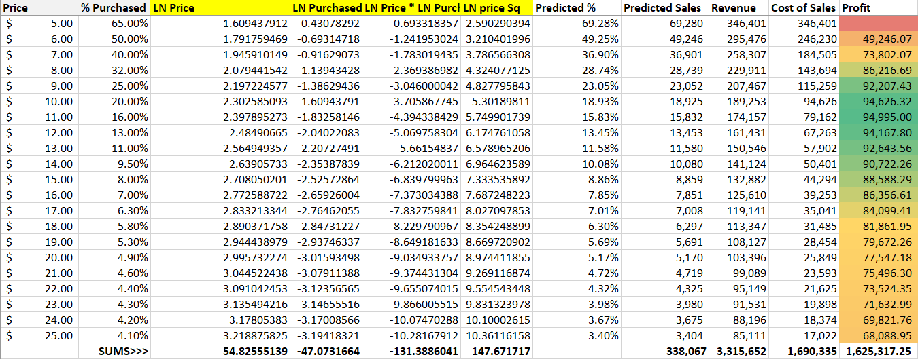

The data presented here highlights some key metrics concerning price point:

At a $5.00 per book price point, the store brings in the most revenue at $346,401. Consequently, if we charged $25.00, it would only yield $85,111 in revenue. Inversely, these two price points represent the highest and lowest Cost of Goods Sold number respectively. This cursory review of the data may lead to poor decisions by some users of this data.

A more accurate indication concerning the success of book sales is to analyze profit: or Revenue at each price point for Predicted Sales - Cost of Goods Sold based on the cost of book ($5) for each Predicted Sales level. If the store charged anywhere between $8.00 and $16.00 for the new Harry Potter sequel, profits would be maximized. This profit ranges from $94,995 at a price optimization of $11.00 per book to $86,216.69 at $8.00 per book.

1. *Optimization analysis (with constraints)*
   1. *Calculate the price point for the highest profit possible*
      1. *The publisher will sell the books at $5 each with no minimum order*
      2. *The publisher has agreed to sell you the books at $4.50 each if you sell at least 30,000*
      3. *The publisher has agreed to sell you the books at $4.00 each if you sell at least 50,000*

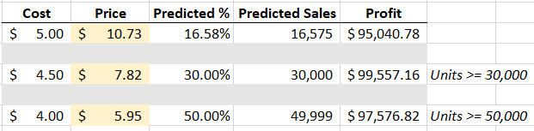

* 1. *Run a constrained optimization for each of the above situations to determine which cost point (from the publisher) and price (to your customer) maximizes your profit. Which cost point should you accept from the publisher?*

In review of the results from the constrained optimization analysis, it is clear to see that the highest profit comes at a cost of $4.50 and a selling price of $7.82 to customers. This scenario required a minimum purchase order of 30,000 units and ultimately yielded a profit of $99,557. This analysis was performed using the Solver feature in Excel. Below is a visual representation of the results.

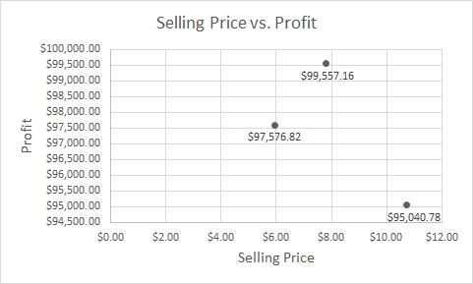

1. *Discussion*
   1. *What are the risks of using Harry Potter 7 in predicting your new demand curve for the Harry Potter Sequel?*

One of the potential risks in using Harry Potter 7 in this analysis is that it does not provide any assumption for a scenario where the new book is not as successful as its prequel. Should the book turn out to be a total flop, or be reviewed poorly, readers will be unwilling to pay at many of the above price points. Inversely, if the book turns out to be Rowling’s best one yet, they may be willing to pay a higher price for the novel. To continue with this sentiment, the plan only reviews trends from the 7th book in the series, ignoring the prior 6 novels. To accurately predict sales for the 8th book in the series, the data set should account for trends which may have been occurring previously. For example, if the series were in a state of decline and the seventh book had the poorest results to date, then the assumptions used for the newest novel in the series should be adjusted downward. Any change to our 100,000 customer input will result in different findings than is shown here.

* 1. *What other data would you like to have to perform your analysis?*

To add even more color to this analysis, we would like to have access to trends for all books in the series including trends on reviews. Knowing how consumers were reacting to Rowling’s most recent work would allow us to know if she was gaining in popularity or not. This would have impacts on the price and quantity of books sold.

We would also want to understand the different media which these books are being consumed on. For example, the price of an eBook may be much less than a physical copy, but because more individuals are using eReaders to read books, revenues may be higher. Also, as audio books continue to grow in popularity, there may be some interesting data concerning profitability which could drive marketing and advertising dollars.

Another important aspect to consider is demographics. Knowing more about our customers, such as location, age, etc. would be very useful information. Furthermore, considering things like the current state of the economy would tell us if people would be willing to potentially pay more or pay less for a book.

Finally, it would be important to understand the economic atmosphere at the time of release. If the book is being released during a recession one could expect sales to decline from years prior. Also considering, if we were in an economic boom and people had a willingness to pay more could also be a factor. A prime example is the current coronavirus pandemic in which movie theaters and studios have pushed back the release of their major films in order to compensate for current market conditions.

Utilizing tools such as Google Analytics would be very useful in helping us obtain some of this valuable information.